12/10/2026
Instructor: Sir Mustajab
Submitted by: Wasif Ali
Reg id: 245187
Class: BSCS F24 B


AGENTS
Artificial Intelligence Lab 06
Lab No 06
Lab Task 1:
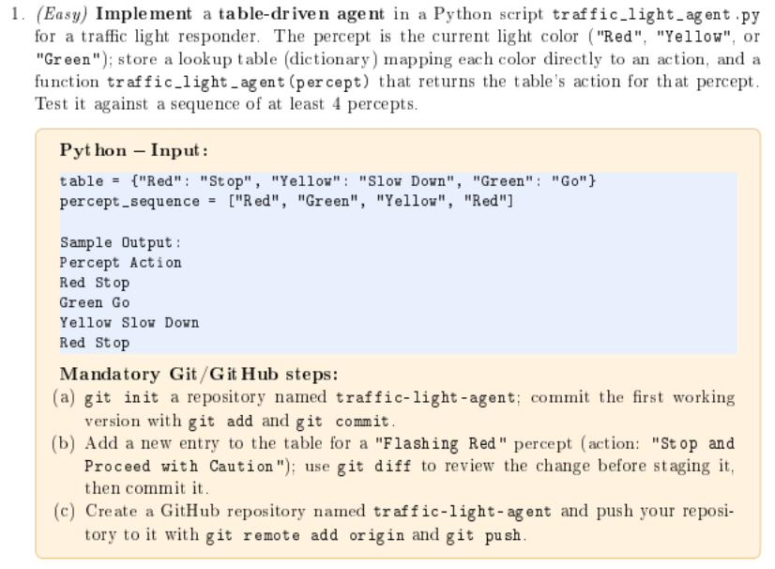
Code:
table = {
"Red": "Stop",
"Yellow": "Slow Down",
"Green": "Go",
}

percept_sequence = ["Red", "Green", "Yellow", "Red"]

def traffic_light_agent(percept):
return table.get(percept)

print("Percept\tAction")
for p in percept_sequence:
action = traffic_light_agent(p)
print(f"{p}\t{action}")
Git Commands
Initialize and commit the first version:
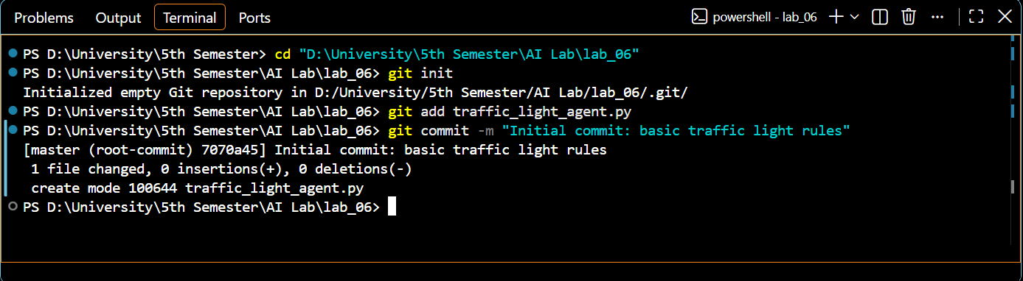
Add the "Flashing Red" entry to the script, review with git diff, then stage and commit:
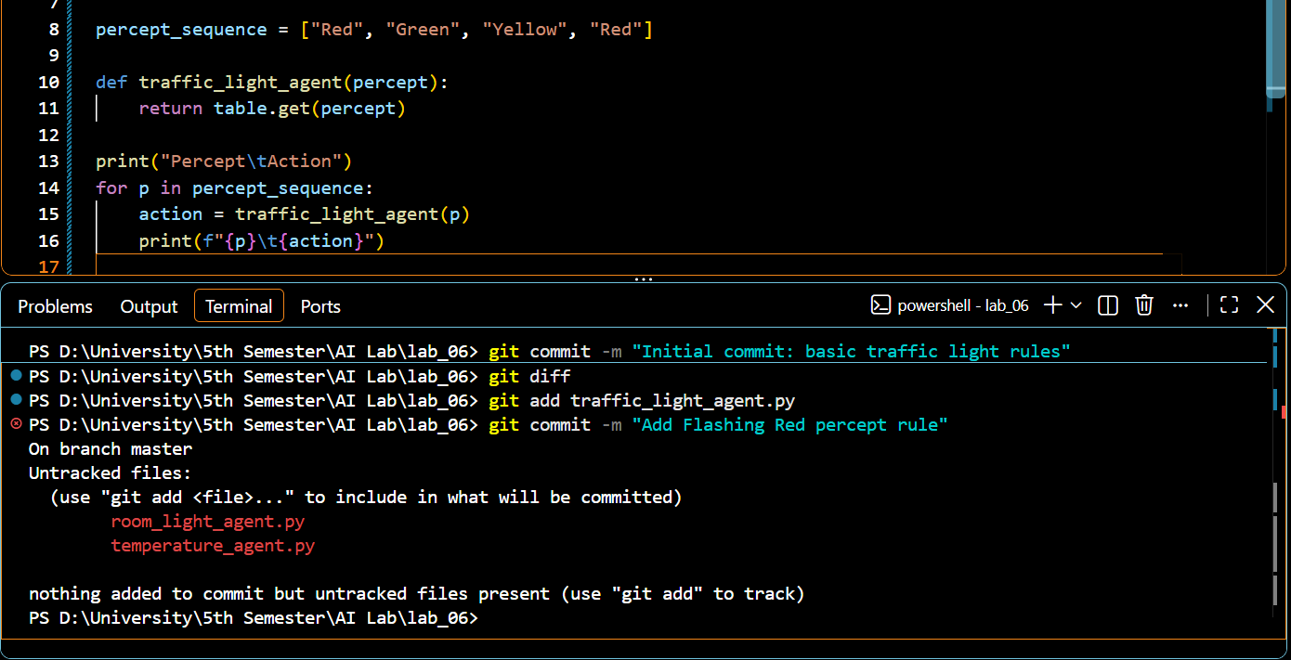
Push to GitHub:
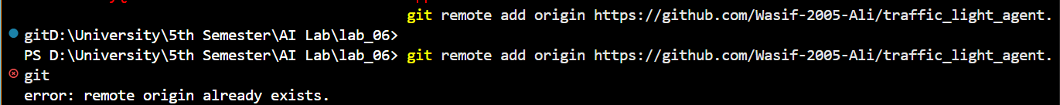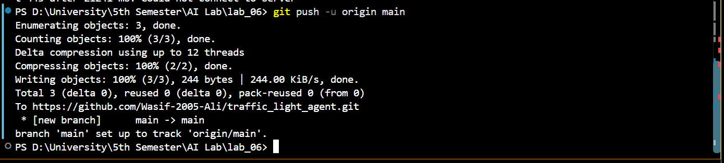

GITHUB VIEW:
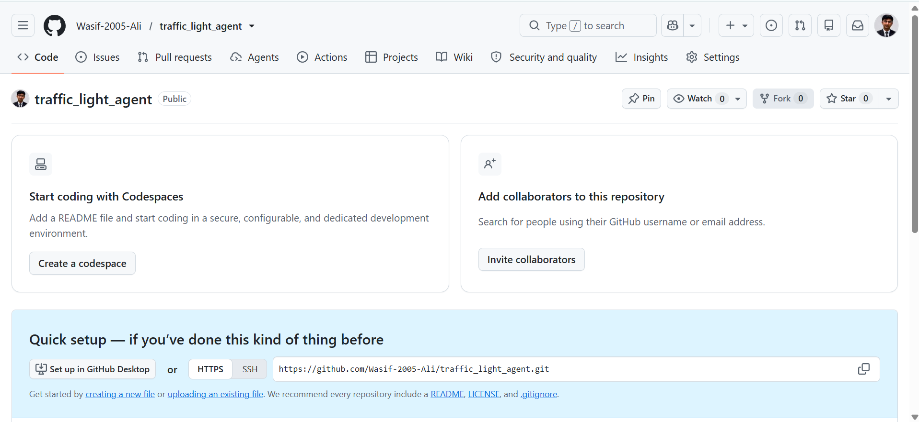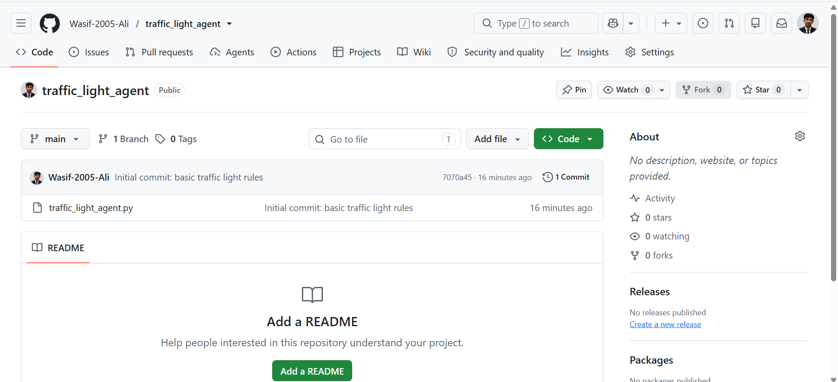

Lab Task 2:
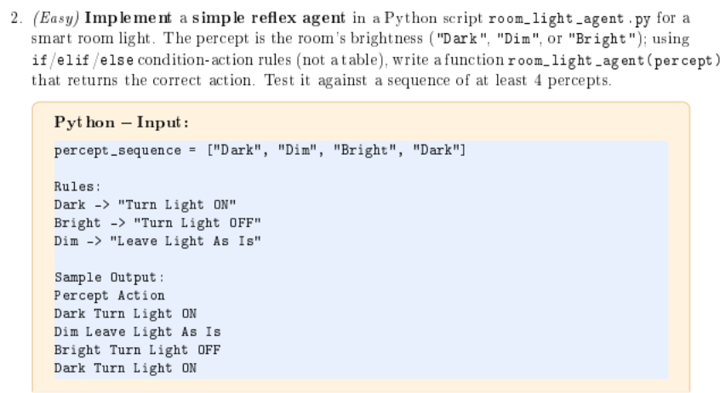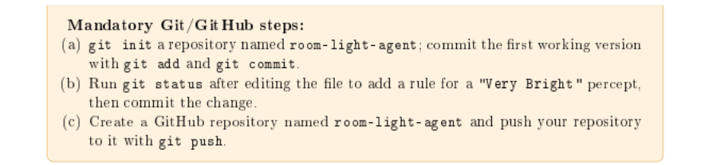
Code:
percept_sequence = ["Dark", "Dim", "Bright", "Dark"]

def room_light_agent(percept):
if percept == "Dark":
return "Turn Light ON"
elif percept == "Bright":
return "Turn Light OFF"
elif percept == "Dim":
return "Leave Light As Is"
elif percept == "Very Bright":
return "Turn Light OFF completely"

print("Percept\tAction")
for p in percept_sequence:
action = room_light_agent(p)
print(f"{p}\t{action}")

Git Commands
Initialize and commit the first version: 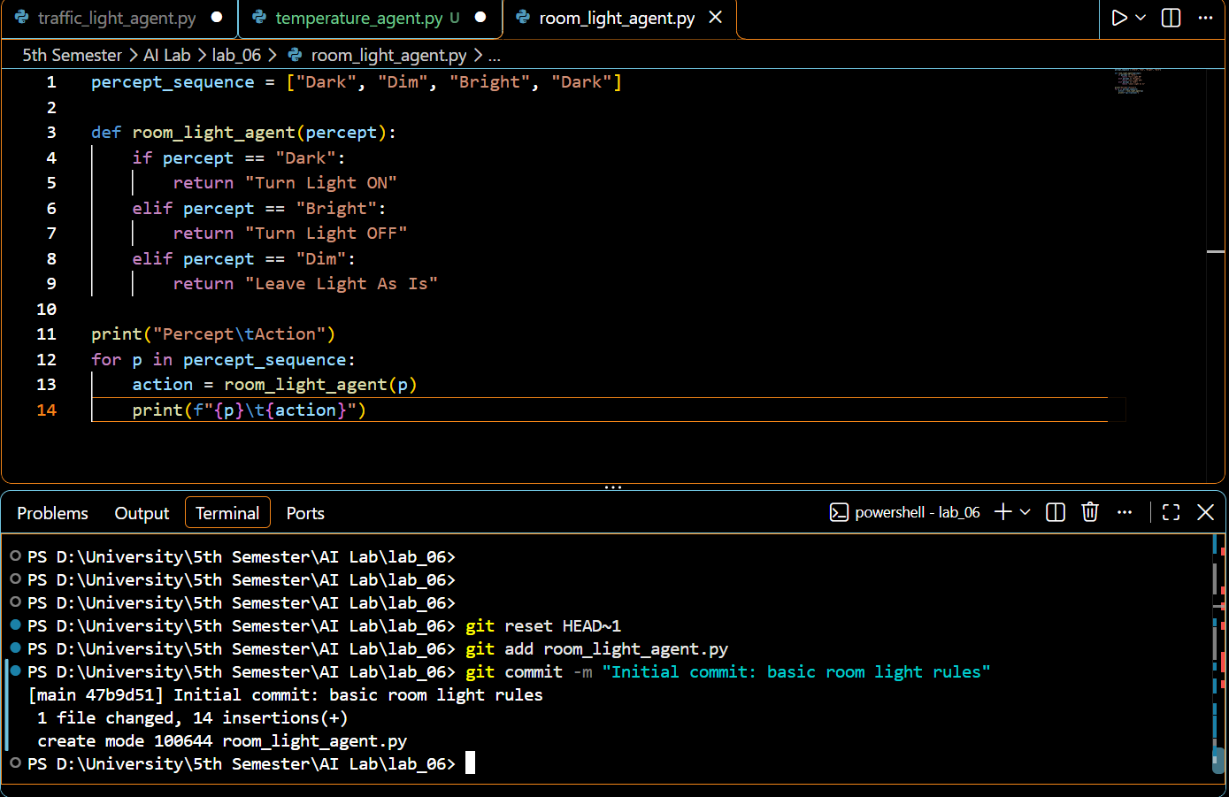Add the "Very Bright" rule to the code, check status, and commit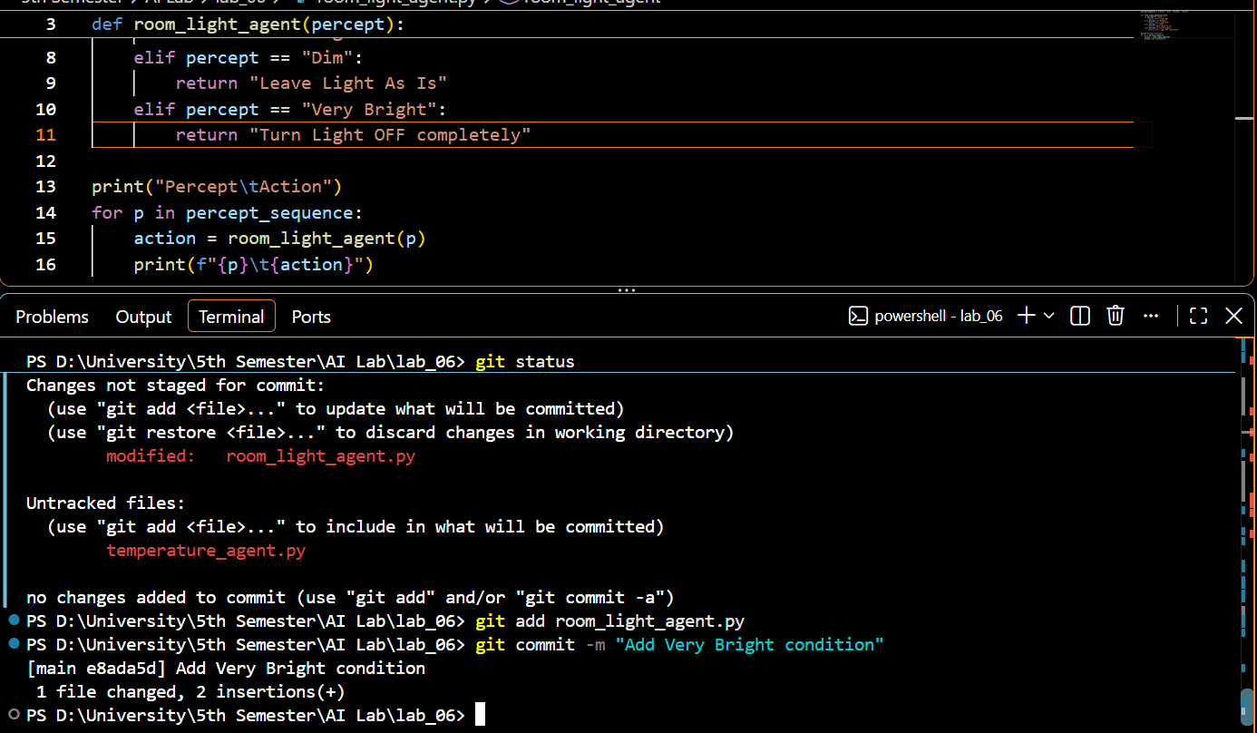
Push to GitHub
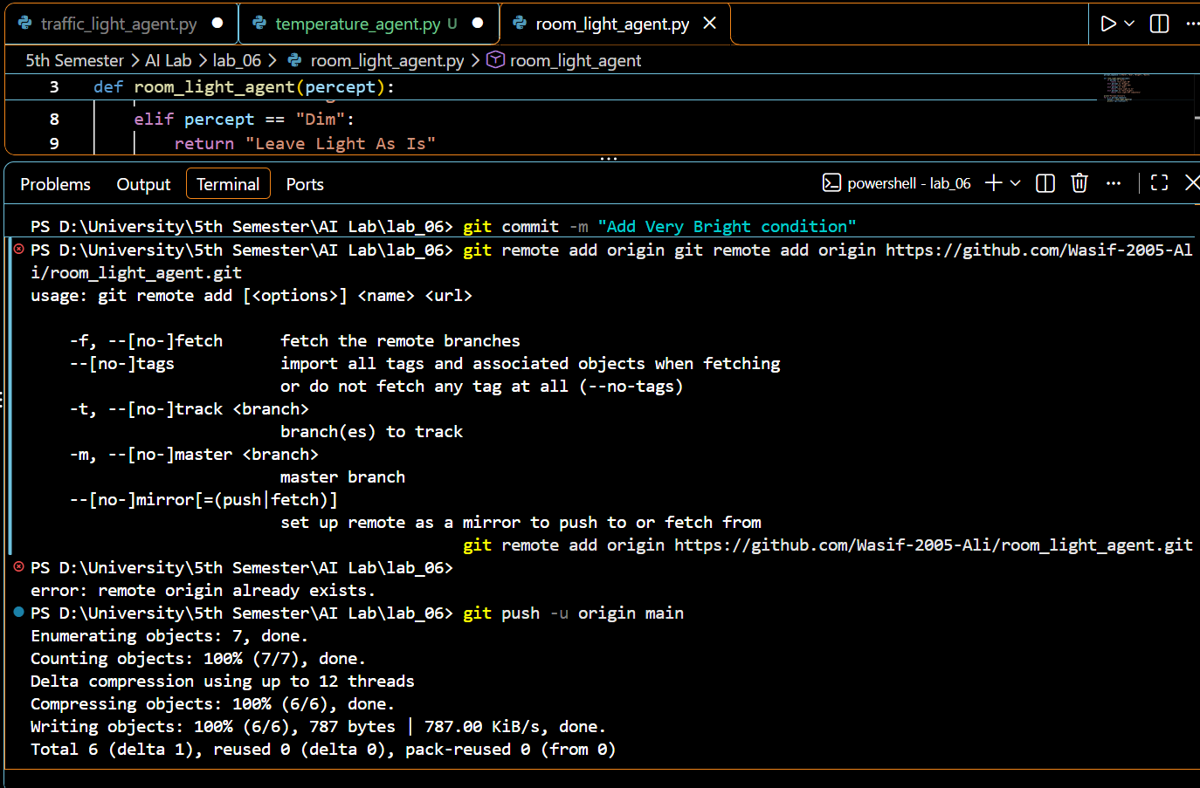

Lab Task 3:
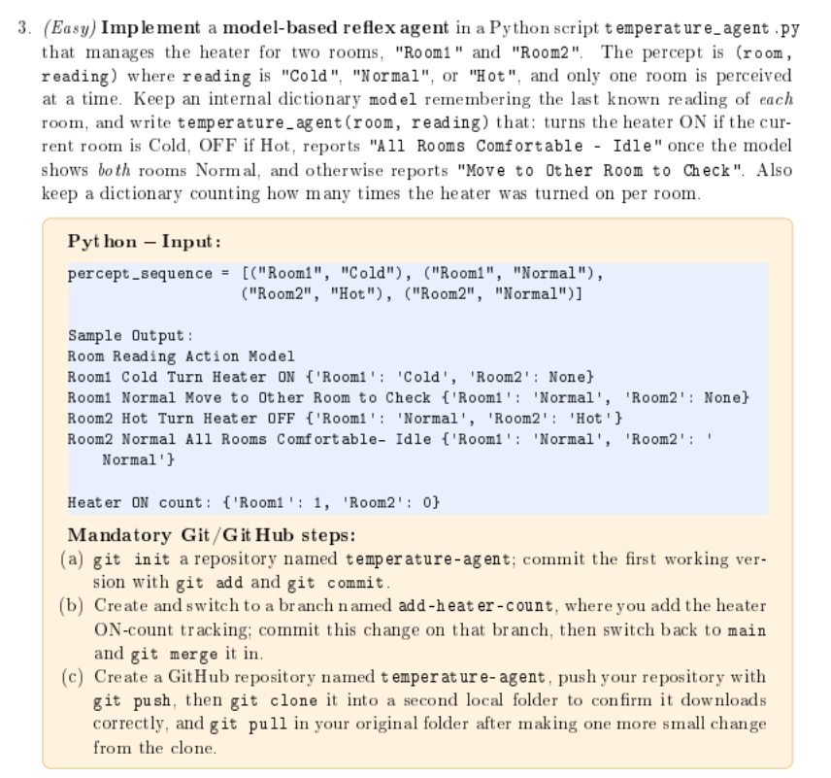
model = {'Room1': None, 'Room2': None}

def temperature_agent(room, reading):
model[room] = reading

if reading == "Cold":
return "Turn Heater ON"
elif reading == "Hot":
return "Turn Heater OFF"
elif model['Room1'] == "Normal" and model['Room2'] == "Normal":
return "All Rooms Comfortable Idle"
else:
return "Move to Other Room to Check"

percept_sequence = [("Room1", "Cold"), ("Room1", "Normal"), ("Room2", "Hot"), ("Room2", "Normal")]

print('Room\tReading\tAction\t\t\t\tModel')
for room, reading in percept_sequence:
action = temperature_agent(room, reading)
print(f"{room}\t{reading}\t{action}\t{model}")
Git Commands: (Initialize and commit the first version (without the heater count))
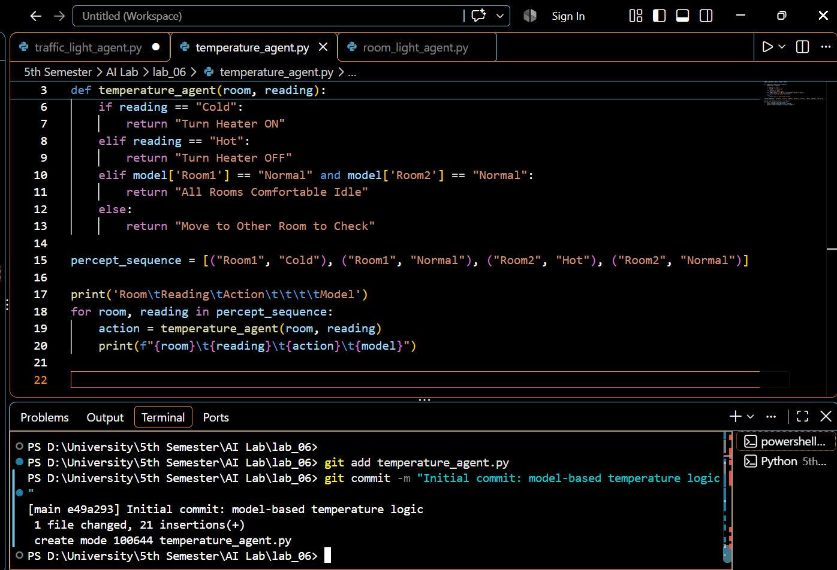
Create the branch, add heater counting logic in the code, commit, and merge back to main:
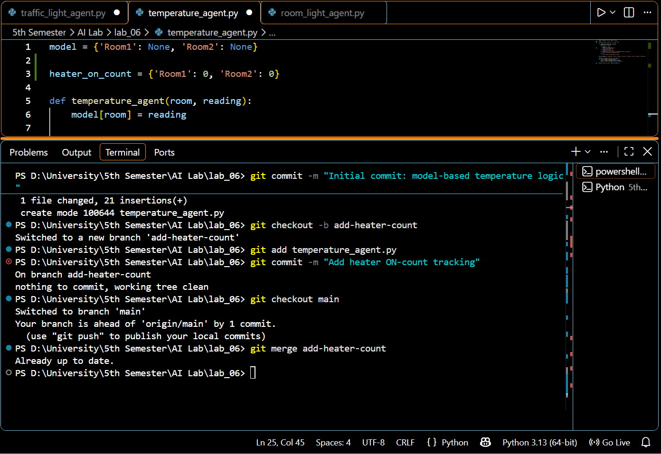
Push, clone into a second folder, and pull updates:
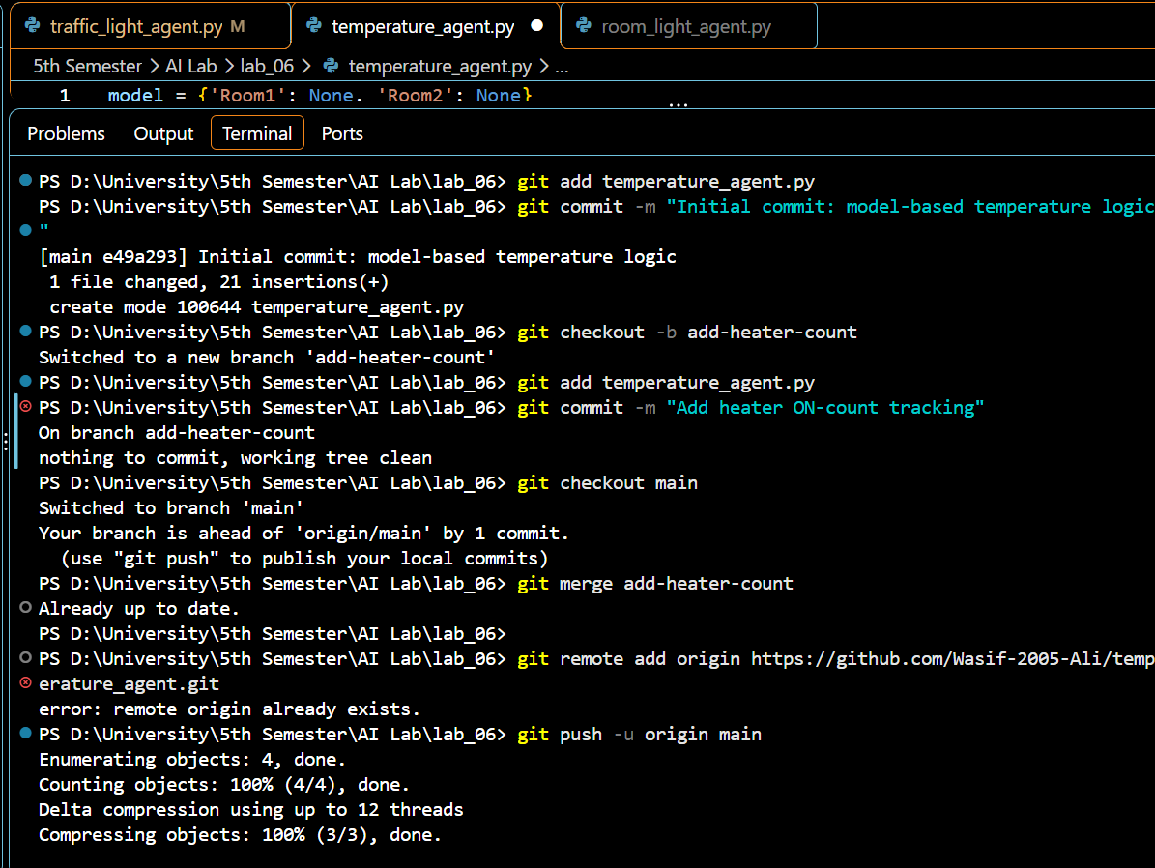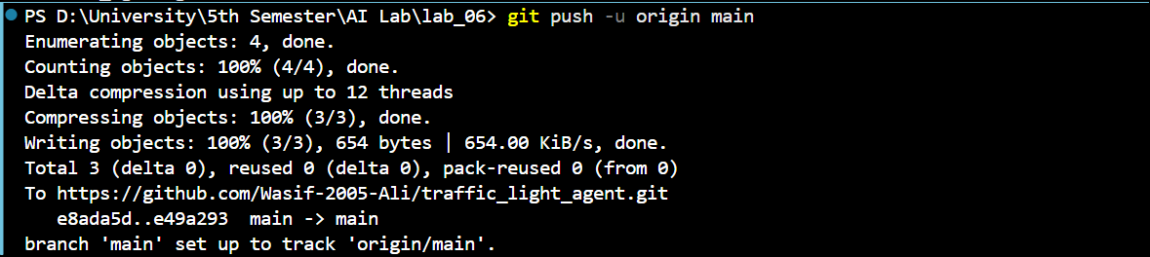
ALL TASK COMPLETED SUCCESFULLY

